**MAIN SCREEN:**

Here’s how I think the opening screen could look. The only other thing that needs to be changed on it is the boot-shaped clouds, which should be removed for this screen.

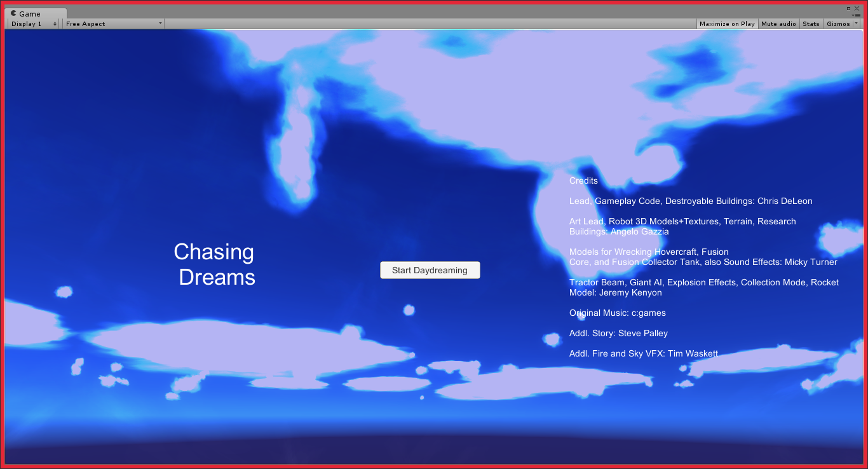

**INTRO SCREEN:** The player is brought here after clicking ‘Start Daydreaming’ on the Main Screen.

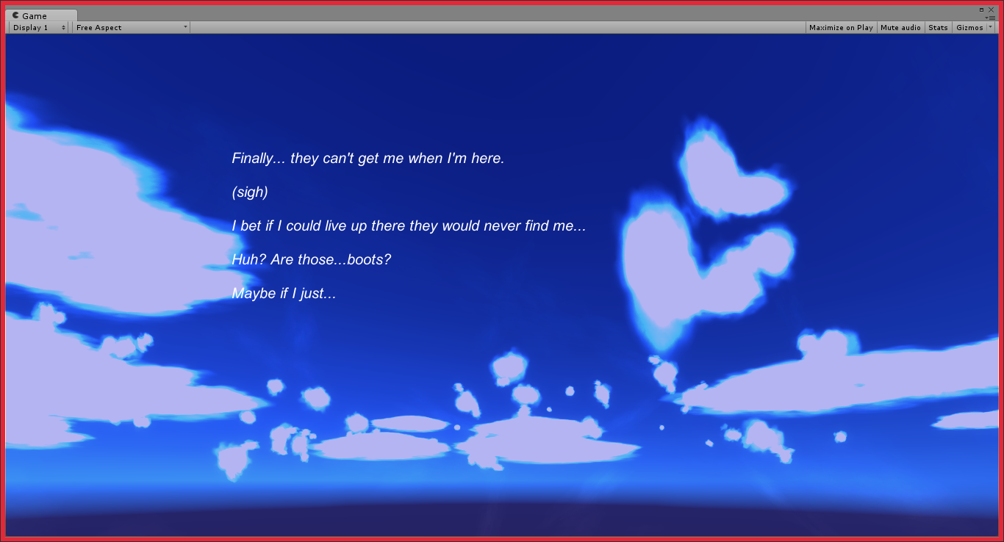

**Text displayed:**

*Finally... they can't get me when I'm here.*

*(sigh)*

*I bet if I could live up there they would never find me...*

*Huh? Are those...boots?*

*Maybe if I just...*

**Boot-shaped clouds button:**

If possible, the player clicks anywhere on them to start the game.

**GAME SCREEN:** The player is brought here after clicking on the boot-shaped clouds on the Intro Screen. Text will appear, as detailed below.

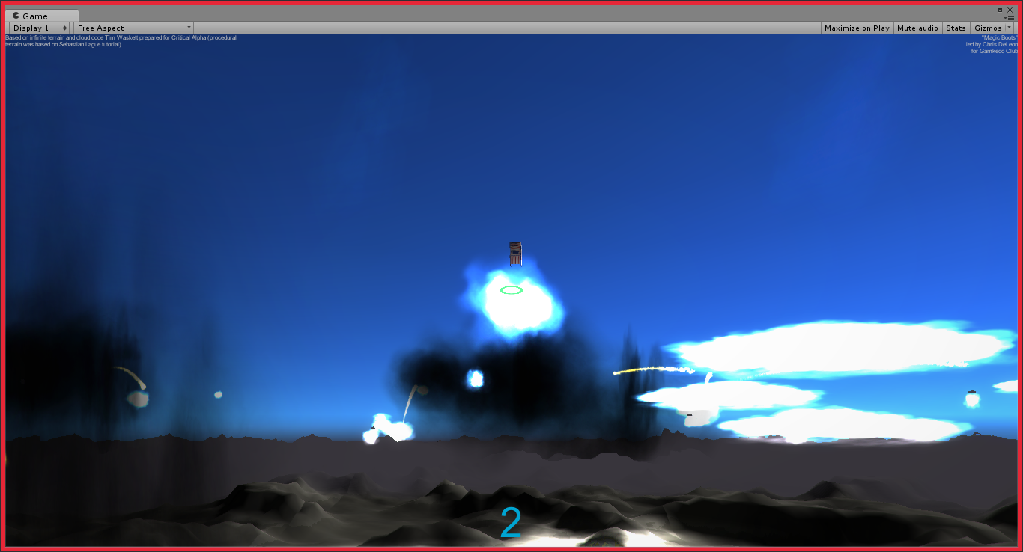

**Text displayed** (positioned in the same general area as the intro text)**:**

*The boots worked!*

*I can't believe I'm--*

*Oh, no...*

*How did they find me here?*

*I’d better get movin’.*

**Text displayed AFTER a toy/treasure is obtained** (positioned in the same general area as the intro text)**:**

*This is my toy!*

*They’re everywhere…*

*I’ve gotta get them back.*

**‘LOSE’ SCENARIO:**

The current text, “Your nightmares caught up to you,” works great.

**‘WIN’ SCENARIO** (I’m not sure how many toys are scattered around, but I assume collecting all of them is how the player wins)**:**

You saved your toys and overcame your fears